Задание 1.

Задание 2.

|  |  |  |  |  |  |  |  |  |
| --- | --- | --- | --- | --- | --- | --- | --- | --- |
|  |  |  |  |  |  |  |  |  |
|  |  |  |  |  |  |  |  |  |
|  |  |  |  |  |  |  |  |  |
|  |  |  |  |  |  |  |  |  |
|  |  |  |  |  |  |  |  |  |
|  |  |  |  |  |  |  |  |  |
|  |  |  |  |  |  |  |  |  |
|  |  |  |  |  |  |  |  |  |

Задание 3.

Задание 4.

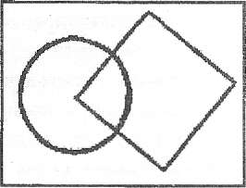

Задание 5.

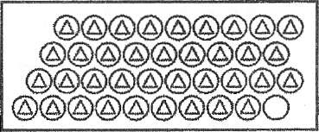

Задание 6.

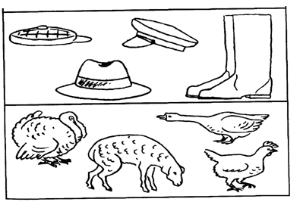

Задание 7.

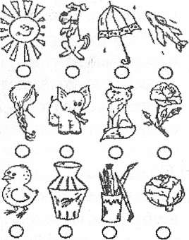

Задание 8.



      
      
      